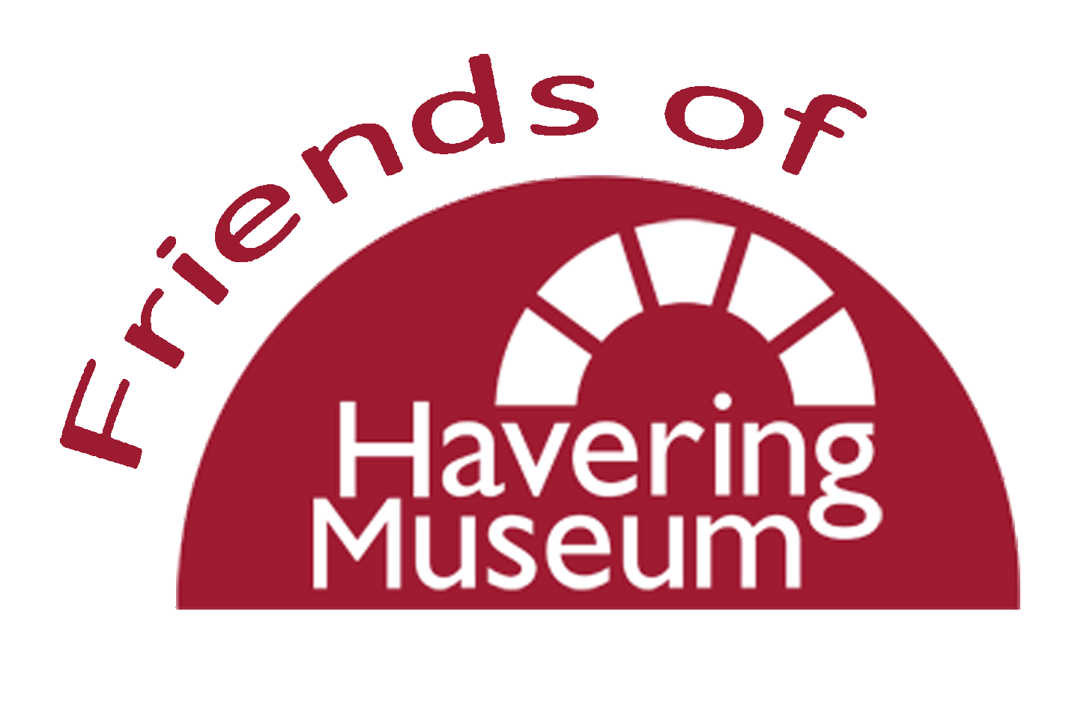
Programme of Events Feb – May 2024

Thurs. 29th Feb The Foundling Museum and its Archive
Talk by Janette Bright

Sat. 9th March The Titanic: The unsinkable ship
Talk by Peter Owen

Wed. 20th March A History of Havering
Talk by Dennis Lynch

Wed. 17th April The London Docks
Talk by John Lynch

Wed. 15th May Tour of Havering Museum
Led by Brian Evans

All events start at 1.30pm and take place at
Havering Museum 19-21 High Street, Romford RM1 1JU

Free to ‘Friends’ members. Open to the public at £5 per ticket
Please book in person or phone 01708 766571
Wed – Fri, 11am - 4.30pm

